**HORMISDALLEN SCHOOL - KYEBANDO**

**PRE- PLE SET 1 EXAMINATION, 2023**

**PRIMARY SEVEN ENGLISH**

**Duration: 2 Hours 15 Minutes**

**NAME: ______________________________________________ STREAM: _________**

INDEX NO.

EMIS NO.

**SECTION A (50 MARKS)**

***In each of the questions 1 to 5, fill in the space with the most suitable word.***

1. Veterinarians prefer treating animal injuries _____________ treating diseases..
2. The late Mutiini was survived _____________________ the children.
3. He is such ________________ honest man that he had to pay his debt in time.
4. The __________________ will come to repair our broken water pipe.
5. The candidates will break _____________ for holidays next week.

***In questions 6 to 15, use the word in brackets to complete the sentences correctly***

1. Our maid is ____________________ the crockery in the cupboard. (put)
2. Prisca dressed up ____________________ and went out. (hurry)
3. All the applicants have received their __________________ letters. (admit)
4. My nephew took the ____________________ position in the competition. (twelve)
5. Mr. Okoth bought a machine to _______________ his family’s drinking water. (pure)
6. Kisoro is a ___________________ district. (mountain)
7. Our cat cat _______________________ a very big rat yesterday. (catch)
8. Mzee Mwambu ____________________ visits his farm. (regular)
9. The _______________________ was arrested for disobeying traffic regulations. (drive)
10. Of the two girls, Shamim is the _____________________________ (clever)

***In questions 16 & 17, write the full form for the given abbreviations.***

1. I’m ________________________________________________________________________
2. Rev. _______________________________________________________________________

***In each of the questions 18 to 20, rewrite the sentence giving one word for the underlined group of words***.

1. The activity of preparing a meal is very interesting.

______________________________________________________________________________

1. The candidates should revise their books in a silent way.

______________________________________________________________________________

1. The man who sells flowers is my brother.

_______________________________________________________________________________

***In questions 21 and 22, give the plural form of the given word.***

1. oasis _____________________________________________________________________
2. valley _____________________________________________________________________

***In questions 23 and 24, use each of the given words in a sentence to show that you know the difference in their meaning.***

1. sin : ____________________________________________________________________________
2. scene: _________________________________________________________________________

***In questions 25 and 26, re-arrange the given words in alphabetical order.***

1. pedestrian, motorists, tyre, bolt

________________________________________________________________________________

1. creep, clean, care, cease

________________________________________________________________________________

***In each of the questions 27 and 28, rewrite th sentences giving the opposite of the underlined words.***

1. The bank does not allow **deposits** at night.

________________________________________________________________________________

1. The war in Sudan **ended** seven months ago.

________________________________________________________________________________

***In questions 29 and 30, rearrange he given words to form correct sentences.***

1. born you in year which were?

_______________________________________________________________________________

1. finish to take will long work How you that?

_______________________________________________________________________________

***In each of the questions 31 to 50, re-write the sentences as instructed in the brackets.***

1. Ebulu is my friend. Okiror is my friend.(**Rewrite as one sentence beginning: Both ……)**

_________________________________________________________________________________

1. If you do not start the journey early, you will be late for the meeting.

(**Rewrite as one sentence using …..……..unless……**…….)

_________________________________________________________________________________

1. I am a disciplined student, ………? (**Rewrite adding a suitable question tag**.)

______________________________________________________________________________

1. That girl needn’t have phoned her mother. (**Rewrite using………. necessary…….)**

_______________________________________________________________________________

1. “Catherine will clean the classroom today, said the class monitor.

(**Rewrite using ……….said that….…….…..)**

_______________________________________________________________________________

1. The meat was very hard. The little boy could not chew it.

(**Rewrite using……………too…………to** …..)

_______________________________________________________________________________

1. There was almost no water in the pot. (**Rewrite the sentences using ……any**…..)

______________________________________________________________________________

_______________________________________________________________________________

1. Ronaldo scored the first goal. (**Rewrite the sentence ending: …….……Ronaldo**)

_______________________________________________________________________________

1. Neither the host nor the guest ate food.(**Rewrite as two separate sentences**)

_______________________________________________________________________________

1. I looked through the window. I saw it was going to rain.

(**Rewrite the sentence beginning: Looking:………….…..)**

______________________________________________________________________________

1. The teacher told me to take his books to the staffroom.

(**Re-write ending:…..………………..said the teacher**)

_______________________________________________________________________________

1. That is my friend’s bicycle. (**Rewrite the sentence using ……owner…....)**

________________________________________________________________________________

1. Despite the fact that I went to the bank early, I did not find the manager.

(**Rewrite the sentence beginning: Although ……….……………..)**

________________________________________________________________________________

________________________________________________________________________________

1. Nalule reads novels. She wants to improve her English.

(**Rewrite using:…….…in order……………..)**

______________________________________________________________________________

1. Both roads lead to the new hospital.

(**Rewrite the sentence beginning: Either………….)**

_______________________________________________________________________________

1. We visit the nurse every time we feel sick.(**Rewrite using……whenever……..…)**

________________________________________________________________________________

1. Mrs. Mwesigwa enjoys roasted potatoes. Mrs. Mwega enjoys roasted potatoes too. (**Rewrite as one sentence using….. ….and so**)

_______________________________________________________________________________

________________________________________________________________________________

1. Drivers should not drive on the pavements.(**Rewrite using: ……… mustn’t ………..)**

_______________________________________________________________________________

1. We may sit for an examination at the end of this term.

(**Rewrite and use: ……………...likely……….………)**

______________________________________________________________________________

1. An atlas is important. A dictionary is important.

(**Rewrite as one sentence using …………. as……….as**)

______________________________________________________________________________

1. ***Read the passage below carefully and use it to answer the questions that follow in full sentences.***

It was in November 1994 when I remembered how the government and teachers had always warned us against cutting down trees and destroying wetlands, but this was too late. The prolonged drought which had begun seven months before then had started causing disaster to Eastern region of our mother land, Uganda. Most of the crops dried up and the livestock started **perishing**.

The disaster invited poverty and famine amongst the entire population. It led to death of some people. Much as the government gave some relief items live food to the citizens, nothing much changed for better because the four kilogrammes of maize flour given to each family regardless its size seemed like a single rain drop falling in to an ocean.

Stories about this drought and its effects appeared in the media day in day out. The most shocking one were; people resorting to eating termites in Kumi district and an expectant mother falling off a mango tree and dying instantly as she was searching for some young mangoes to save her starving family.

These stories became a a wakeup call to all people.

Come March the following year, a few rain drops landed on the ground. It was a moment of panic! Everyone picked up the garden tools and seeds rushed to the garden. Thank God! The better the forests we had re-afforested grew, the heavier and more reliable rains we kept on receiving. We started getting some better harvests. The situation showed some great signs of improvement.

Fellow citizens, let us preserve the environment and store some food in granaries.

**For God and My Country**.

**Questions**.

1. What is the above story about?

____________________________________________________________________________

1. Why did the drought begin?

____________________________________________________________________________

1. How did the government and teachers try to prevent the drought from coming?

_____________________________________________________________________________

1. Where did the prolonged cause the disaster?

______________________________________________________________________________

1. How did the government save people’s lives during the disaster?

_____________________________________________________________________________

1. What did the disaster invite?

_____________________________________________________________________________

1. When did a few rain drops land on the ground?

_____________________________________________________________________________

1. Give another word or group of words similar to the word perishing as used in the passage.

_____________________________________________________________________________

1. How did the writer advise his fellow citizens according to the story?

_____________________________________________________________________________

_____________________________________________________________________________

1. Suggest a suitable little to the passage.

______________________________________________________________________________

1. A) ***The information below was recorded in Zijjan’s directory on 10th May 2011, study it carefully and then answer the questions that follow in full sentences***.

|  |  |  |
| --- | --- | --- |
| **Name** | **Network** | **Telephone number** |
| Alex | Mango | 0712678834 |
| Ivan | MTN | 0772563326 |
| Alice | MTN | 0773801148 |
| Babirye | Mango | 0715702438 |
| Bebon | Orange | 0791354669 |
| Gloria | Airtel | 0750915270 |
| Christian | Airtel | 0753007154 |
| Denis | Orange | 0791679853 |
| Eve | MTN | 0784154015 |
| Felicia | Warid Telecom | 0701638527 |

**Questions**

1. Where was this information recorded?

____________________________________________________________________________

1. What was the above information about?

____________________________________________________________________________

1. How many MTN subscribers did Zijjan’s record in this directory?

____________________________________________________________________________

1. Whose number was **079169853**?

_____________________________________________________________________________

1. Write telephone number in short form.

**_____________________________________________________________________________**

(B) ***The information below was pinned at the gate of Wambuzi Junior School Katooke. Study it carefully and answer the questions in full sentences***.

**DEBATE BEBATE**

**MOTION**: **Primary School Students Should Possess Mobile Phones while**

**at School**.

**PROPOSERS**: Modern Era Primary School

**OPPOSERS**: Takajjunge Primary School -Mukono

**VENUE**: Meta Town Hall

**DATE**: Fri 10th July 2023

**TIME**: 2:00P.m- 4:10P.m

**NOTE**: A free soda will be given to all good speakers.

**Questions**

1. Where did the information appear?

____________________________________________________________________________

1. Which school debated in favour of the motion?

_____________________________________________________________________________

1. How long will the debate last?

_____________________________________________________________________________

1. Where was the debate held?

______________________________________________________________________________

1. Why do you think many people might have tried to speak during the debate?

______________________________________________________________________________

1. ***Study the school pay-in-slips below carefully and then use it to answer the questions that follow in full sentences***.

|  |  |  |
| --- | --- | --- |
| **MPOMA JUNIOR SCHOOL**  **P.O BOX 300 MUKONO**  **BANK OF AFRICA**  **A/C 0117900831**  **School copy**  **Serial No. 697**  **Pupil’s Name: Kato Abed**  **Class: P5 Term: I Year 2011**  **Date: 2/2/2011** | | |
|  | **NOTES** |  |
| 50000= | 50000= |
| 20000= |  |
| 10000= | 10000= |
| 5000= |  |
| 2000= | 4000= |
| 1000= |  |
| **COINS** |  |
| 500= | 500= |
| 200= | 1000= |
| 100= |  |
| 50= |  |
| **BANK CHARGES** | 2500= |
|  | **65500=** |
| **Amount in words: Sixty five thousand five hundred shillings only.**  **Deposited by: Kiiza Abdul**  **Signature K.A** | | |

|  |  |  |
| --- | --- | --- |
| **MPOMA JUNIOR SCHOOL**  **P.O BOX 300 MUKONO**  **BANK OF AFRICA**  **A/C 0117900831**  **Parent’s copy**  **Serial No. 697**  **Pupil’s Name: Kato Abed**  **Class: P5 Term: I Year 2011**  **Date: 2/2/2011** | | |
|  | **NOTES** |  |
| 50000= | 50000= |
| 20000= |  |
| 10000= | 10000= |
| 5000= |  |
| 2000= | 4000= |
| 1000= |  |
| **COINS** |  |
| 500= | 500= |
| 200= | 1000= |
| 100= |  |
| 50= |  |
| **BANK CHARGES** | 2500= |
|  | **65500=** |
| **Amount in words: Sixty five thousand five hundred shillings only.**  **Deposited by: Kiiza Abdul**  **Signature K.A** | | |

**Questions**

1. In which bank was the school fees deposited?

_________________________________________________________________________

1. When was the school fees paid?

_________________________________________________________________________

1. Who paid the school fees?

_________________________________________________________________________

1. How much money was paid?

_________________________________________________________________________

1. For whom was the school fees paid?

___________________________________________________________________________

1. How many two thousand bank notes were paid?

___________________________________________________________________________

1. In which class is Kato Abed

_____________________________________________________________________________

1. Write a/c in full.

____________________________________________________________________________

1. For which term was the school fees paid?

____________________________________________________________________________

1. Give the opposite of **deposited**.

____________________________________________________________________________

1. ***The following sentences are in wrong order. Rewrite them correctly to form a meaningful composition***.
2. The government is also called upon to construct better roads.
3. First, we must follow traffic rules and road signs.
4. Together we shall make road accidents and their affects just a nightmare.
5. As road users, we have the best answers to this question.
6. But, how can we ensure road safety?
7. Lastly, we must ensure that our vehicles are in a good mechanical condition.
8. Lastly, we must not drive under the influence of alcohol and other drugs.
9. The police is called upon to help us enforce the above road safety strategies.
10. Thirdly, we must respect each other as we use busy roads.
11. Road safety is important to all road users.

**Correct order**:

___________________________________________________________________________________________________________________________________________________________________________________________________________________________________________________________________________________________________________________________________________________________________________________________________________________________________________________________________________________________________________________________________________________________________________________________________________________________________________________________________________________________________________________________________________________________________________________________________________________________________________________________________________________________________________________________________________________________________________________________________________________________________________________________________________________________________________________________________________________________________________

1. ***The pictures below tell a complete story. Study them carefully and answer the questions about them in full sentences for each picture to show. What is happening in it. You may use any of these words to help you.***

**loading, coffin, carrying, colliding, lying, prayers, head-on, priest, nurse mourners escape, addressing, truck, crossing**

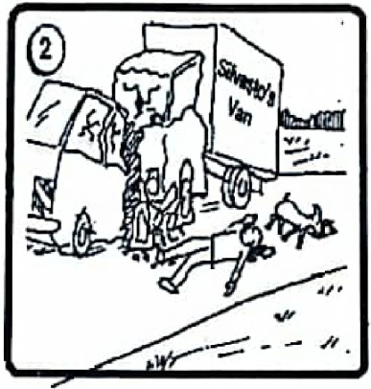

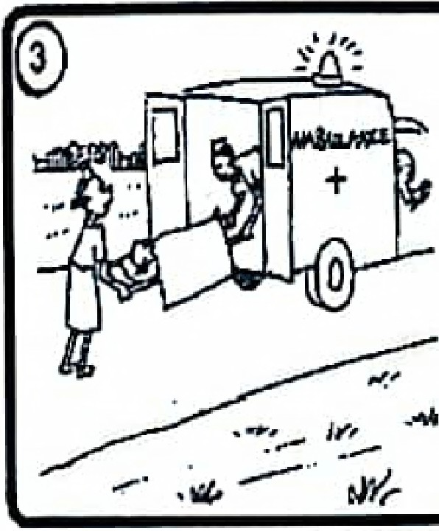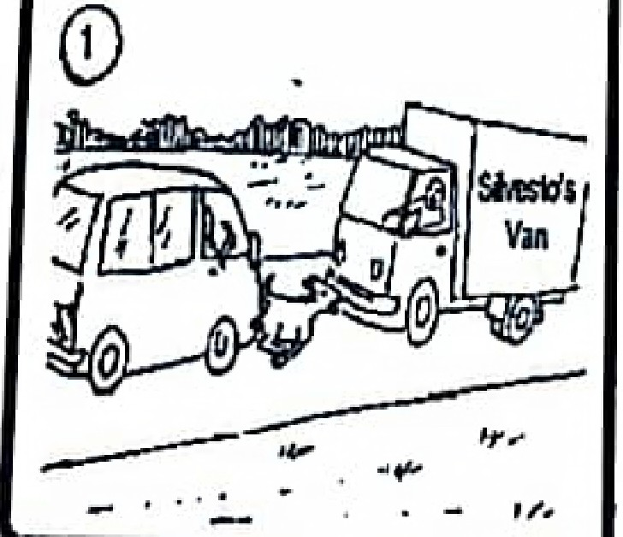

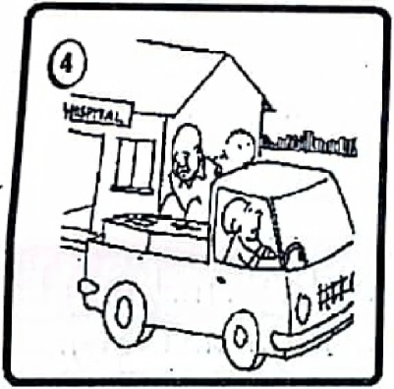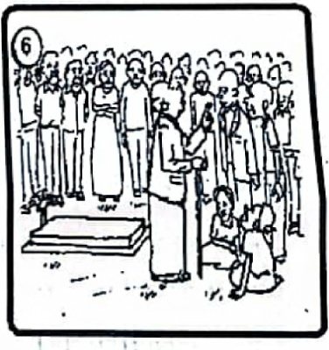

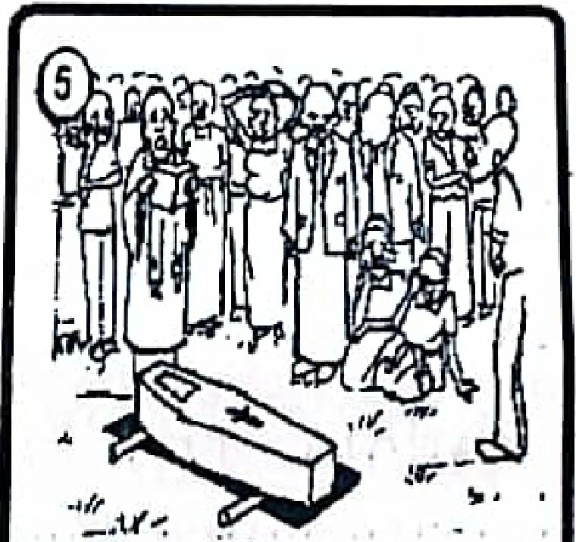

Picture 1: ____________________________________________________________________________

Picture 2 : ____________________________________________________________________________

Picture 3 ____________________________________________________________________________

Picture 4: ____________________________________________________________________________

Picture 5: ____________________________________________________________________________

Picture 6: ____________________________________________________________________________

b) What caused the accident?

______________________________________________________________________________________

c) In picture 4, where do you think the vehicle is going?

______________________________________________________________________________________

d) Who do you think the old man holding a stick might be?

______________________________________________________________________________________

***END***